**Lesson 9 Demo 4**

**Understanding Container Logs**



# Steps to be followed:

1. Logging Docker Container
2. Logging Kubernetes Container

**Step 1: Logging Docker Container**

1. Fetching the container ID for all Docker images using the below command:

**docker ps**

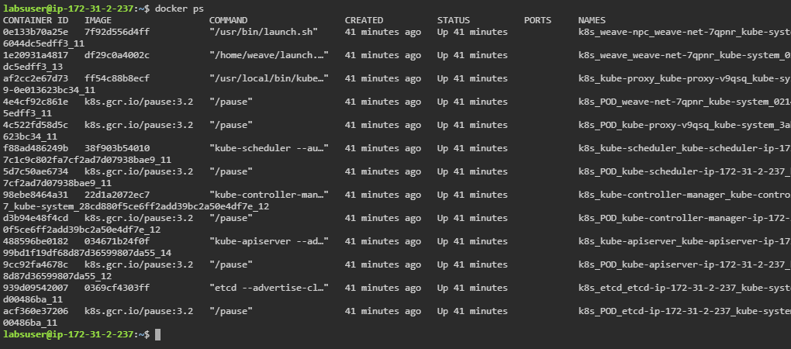

1. Listing the specified container’s logs using the following command:

***docker logs <Container_ID>***

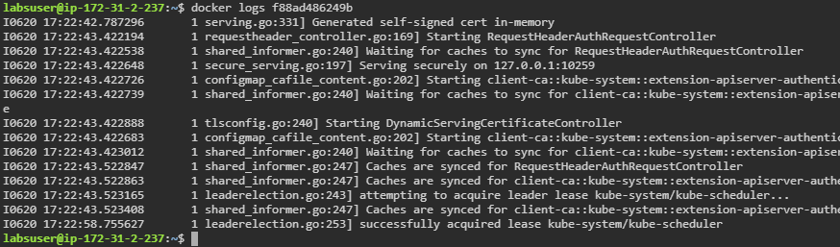

**Step 2: Logging Kubernetes Container**

1. Execute the command to list the containers of the pods that are deployed in the default namespace:

***kubectl get pods -o=jsonpath='{range .items[*]}{"\n"}{.metadata.name}{":\t"}{range .spec.containers[*]}{.name}{", "}{end}{end}'***

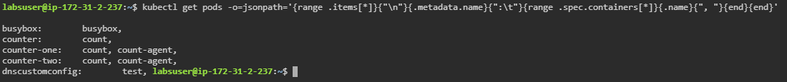

1. Execute the command to list the containers of the pods that are deployed in the default namespace in a sorted order:

***kubectl get pods -o=jsonpath='{range .items[*]}{"\n"}{.metadata.name}{":\t"}{range .spec.containers[*]}{.name}{", "}{end}{end}' | sort***

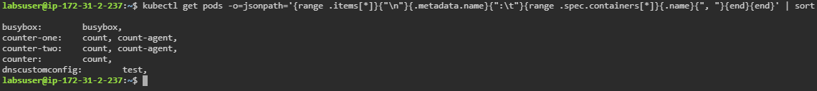

1. Execute the command to list the containers of the pods that are deployed in the all namespaces in a sorted order:

***kubectl get pods --all-namespaces -o=jsonpath='{range .items[*]}{"\n"}{.metadata.name}{":\t"}{range .spec.containers[*]}{.name}{", "}{end}{end}' | sort***

